

Indoor Navigation System



DATE:…………………………..

SUBMITTED BY

SAQUIB NAZEER

ABHINAV TIWARY

AKASH SHARMA

**Table of Content**

|  |  |
| --- | --- |
| Sr. No. | Content |
| 1 | Introduction |
| 2 | IPS Functionalities |
| 3 | Technologies For IPS |
| 4 | Comparison Between various Technologies |
| 5 | Indoor Navigation and Services at Airports |
| 6 | A Running System Provided By Infsoft Frankfurt Airport |
| 7 | Implementation of Indoor navigation System |
| 8 | Conclusion |
| 9 | Bibliography |

**INTRODUCTION**

An indoor positioning system (IPS) is a system to locate objects or people inside a building using lights, radio waves, magnetic fields, acoustic signals, or other sensory information collected by mobiledevices.

Indoor Positioning System (IPS5) is a system of network connected devices which is used for wireless locating objects and persons inside buildings and partly covered areas . Technologies used by those systems become commercially available in various forms (required hardware) and with various characteristics (functionality by means of visual contact, radio-frequency,magnetic field, sound). There are a large number of available technologies that can be used in the IPS system.

Outdoor positioning systems usually use satellite technologies (eg. GPS) or network technologies (determining a location at the base station of the mobile service provider, Wi-Fi ).GPS technology has become widely available in the late 1990’s and has significantly improved the outdoor positioning system. Today, smart devices often have a built-in GPS component.

There is a need for locating in the interior area. Satellite positioning has not been functioning in closed areas, therefore it has led to the emergence of new technologies to make such a positioning possible. Indoor positioning is more complex than the outdoor positioning as the implementation of technologies used indoors may require some additional infrastructure. IPS could be designed to search for items or groups of items in the supermarket, to find the appropriate office within the building of an institution, to orient oneself within the **hospital complex**, to find certain **stores** within the mall, to get around easily at the **airport**, **museum**, etc.

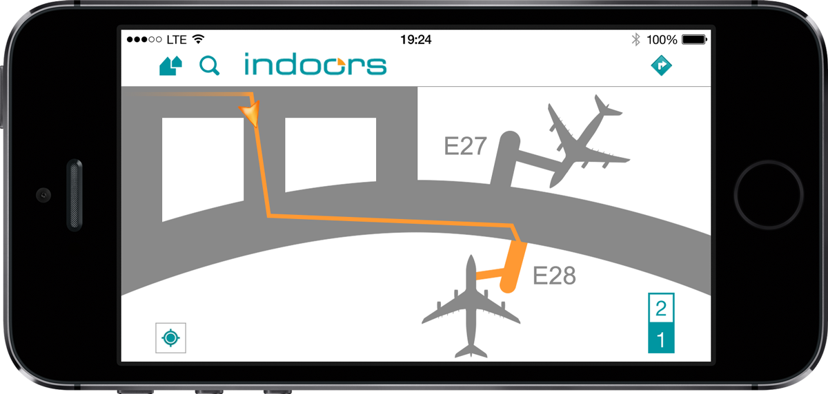

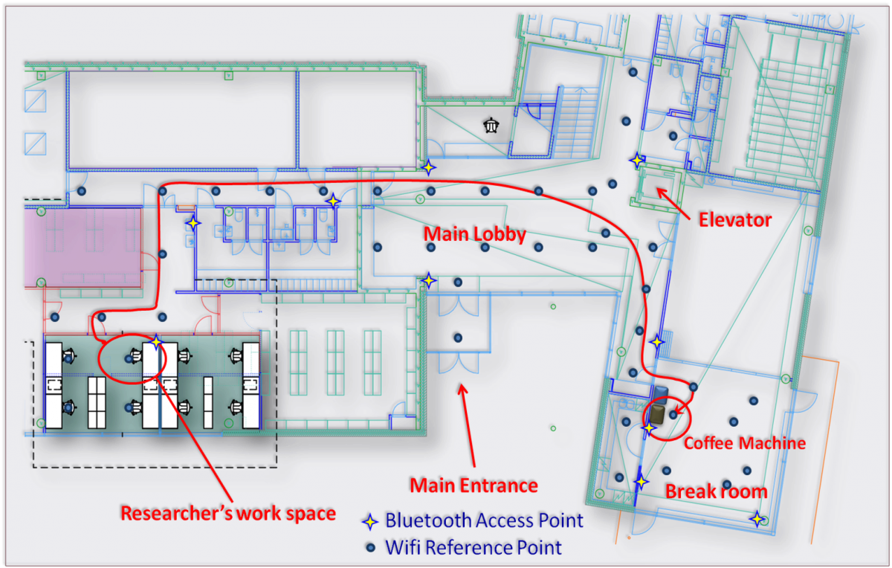

**IPS FUNCTIONALITIES**

Technologies used for indoor positioning vary in accuracy, cost of implementation and installation and maintenance

activities. IPS system is composed of three distinct elements.

• a dynamic platform of the positioning system

• location devices or signal transmitters

• a mobile application that retrieves and interprets signals.

Indoor positioning system constantly operates in order to determine the exact location of the device. The coordinates (latitude, longitude, and height / number of floors) are the output of such operation. In order for the coordinates to be applicable, they need context, that is, a map . Basically, a technology that allows obtaining information on the location of objects within the building results in the following two concepts: knowing when the user is located near a certain point, or being able to determine the position of the user regardless of their location in the building. The first refers to a system based on proximity (PS8 ) and the other is the IPS system .PS uses location devices that operate with Bluetooth9 low energy (BLE10) and it acts as transmitters that broadcast their identification data to nearby smart mobile devices.

The PS is used for the purpose of finding the user’s location (people and things) in certain moments. The location device provides information on the time when a person or thing is located within a range of a certain point, that is, of a location device. This information can be used to “target” customer located near a shop and for sending notifications.

The lack of such a system is the range of transmission. If the implementation of the PS is aimed at achieving greater connectivity with the user, it is necessary to set up location devices at various locations within the building. These location devices can also be a subset of an IPS .

IPS includes a location device as part of a larger system that enables other functionalities for applications: route search, search for friends, enhanced marketing opportunities, detailed analytics.

IPS uses multiple signals from location devices, as well as motion sensors and other sensors on the user’s smart mobile device. By combining these elements, the IPS can accurately calculate the position of the user. Some IPS systems include analytical processes of the system’s basic data and data created during system operation. Such processes can predict the future movement of the user even in buildings with multiple floors.

When searching for a route, the IPS system functions in the same way as the GPS for outdoor positioning. Instead of retrieving the satellite signal, the IPS exchanges signals between the location devices and smart devices’ sensors. The functionality of a route search helps a user to manoeuvre in the area, such as a shopping centre or hospital. The guidance, as well as the prediction of the user’s movement, arebased on the current route. Locating friends works in the same way, allowing users to find each other indoors.

IPS also helps to ensure marketing opportunities. For example, a shopping mall can define arbitrary areas where they want to display information or provide commercial advertisements. Areas can be installed and defined within the IPS system without the need for moving the hardware responsible for sending notifications to customers.

IPS can also provide detailed analysis, even in real time, display user’s movement in the building and enable a user to make decisions. From such analysis it is possible to see which zones in a shopping mall are more frequently visited.. IPS also enables the analysis of customer behaviour, for example, which shops are the most visited, which shop the customer has just passed by and what is his/her route, and even whether the customer has stopped in front of a shop window and in front of which shop window exactly

IPS is also applied at the health care institutions. The system can guide the patient to the office of a specific doctor. Another use of the IPS system in health care involves the use of location devices for medical equipment in order to locate certain equipment more easily, which is particularly useful in emergency cases.

The main difference in the functions of the IPS in relation to the PS is in the fact that the IPS collects data on the movement of the user first and then it can analyse the traffic at certain parts of the system, while for the PS system it is necessary to already know in advance which parts of the system should be analysed in order to timely place the location devices on the desired position.

The Wi-Fi technology was used at the very beginning of the indoor positioning. However, since it was not intended to be used for the purpose of positioning, the positioning was not precise enough and there was also a lot of collaboration between the phone and the network itself.

In Meridian company, at the time, one of their first projects was creating a mobile app for a large and famous museum. The museum was using one of the very first indoor location systems and it operated by measuring Wi-Fi signals to compute user location. These signals tended to fluctuate dramatically and the location quality was very poor as a result. In the museum’s app, the “blue dot” would float wildly around, jumping 30 feet at a time, and it felt very unreliable “Blue dot” represents the user’s movement in the area and it also enhances the user experience. When the user moves through the room the “blue dot” should move smoothly and also be as accurate as possible regarding the user real position. It is equivalent of the real-time location recognition as GPS is in the outdoors.

The “blue dot” was not only showing the movement of the user incorrectly, but it also appeared randomly on the screen. To improve the accuracy of the positioning, the algorithm that would allow this improvement was enhanced. At the same time, the user experience, that is “the blue dot experience” was also worked on, in order to accurately display the user’s movements. The user’s movement from one room to another was also enhanced, without taking into account small intermediate steps meaning Meridian redesigned the entire app experience around the assumption that the user location just was not going to be precise. They focused the “getting directions” experience around going from one big hall full of exhibits to another instead of all small steps that the user takes to get there. The hall exits are perfectly well-marked in the space and the user just needs to know which one is next.

In most cases, the Wi-Fi component is already supported or even included on users’ smart devices, and the buildings can be adequately equipped with the appropriate infrastructure. Sometimes, counters need to be installed at the entrance area, as well as a video camera at specific locations in order to analyse the user’s movement by recording the user’s location.

An administrative interface, the so-called dashboard, may be positioned at the central site, and thus manages the system (updating locations, managing alerts, etc.). Backend software contains the following components :

• system for running location-based alerts,

• analytical system based on movement of the user,

• database containing location information,

• management and security layers to protect data (Administrative Tools),

• integration into existing systems, for example, e-commerce, marketing automation, POS11, content management,

• API12 to import and export data and location-based triggers.

**TECHNOLOGIES FOR IPS**

**BLE**

Bluetooth technology is a wireless communication standard that is used to exchange data at a close distance. It was developed in 1994 by Ericsson, and in 1998 Ericsson, IBM, Intel, Nokia and Toshiba set up a special competent authority, the “Bluetooth Special Interest Group” (SIG). The role of the competent authority is to improve standards, proper implementation and licensing of Bluetooth technology.

The main features of Bluetooth technology are low-cost Bluetooth devices, low power consumption, small range, robustness and global use. Bluetooth provides transfer speed of 1 Mbit/s and uses unlicensed frequency band of 2.4 to 2.485 GHz, that is, it uses ISM area (industrial, scientific and medical) where frequency is globally harmonized. Also, the Bluetooth

offers a radio connection with other systems. Devices from different manufacturers are mutually incompatible, and packet and channel switching is allowed.

To install the BLE technology in devices, Bluetooth 4.0 introduces two modes of operation: single-mode and dual-mode. Single-mode operation includes only the integration of the BLE functionality into the controller, while dual-mode operation allows the integration of BLE and Bluetooth functionality in the standard controller. Device manufacturers have these two options at their disposal and it is important to point out that devices with single-mode operation cannot communicate with devices that use classic Bluetooth protocol

Today, most mobile devices are produced with a support for standard Bluetooth and for the BLE, that is, a Bluetooth microcontroller with dual-mode operation is installed in devices. Mobile operating systems that currently support the BLE are: Android 4.3 and higher; iOS 5 and higher; Windows Phone 8.1; Blackberry 10.

The BLE broadcasts signals from transmitters that operate on batteries. The technology is available on most devices (smartphones, tablets). It uses the so-called beacon-e (transmitter) and location devices that are cheap, small in size, have a long battery life and do not require an external power source. The device detects the signal from the transmitter and can roughly calculate the distance to it and thus estimate the location of the device.

Using the BLE technology, the transmitters notify the nearby devices on their presence. Nearby devices (mobile devices, tablets) can be subscribed to notifications of the transmitters and can receive a variety of content (such as text, images and URL). At the same time, the transmitters can be used for contactless payments in a similar way as NFC1.

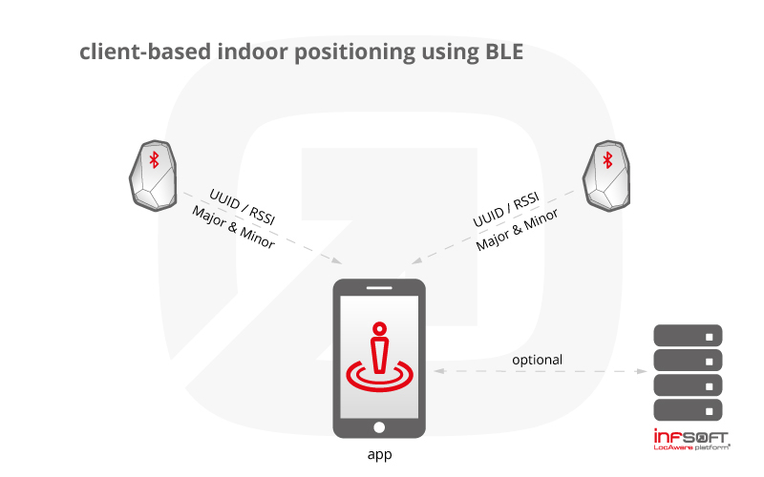

**WPS (Wi-Fi positioning system)**

Wi-Fi is a technology that uses radio waves to connect to the network. Wi-Fi connection is established with the help of a wireless adapter which creates a wireless local area network in the vicinity of a wireless router, which is connected to the network and allows users to access Internet services. Once configured, Wi-Fi allows you to wirelessly connect to devices by emitting frequencies between 2.4GHz and 5GHz depending on the amount of data passing through the network.

The term WPS originated from the Skyhook Wireless company which used the term to outline its Wi-Fi positioning system. Google, Apple, various phone manufacturers and phone operators have drawn up very extensive databases of Wi-Fi access points by connecting Wi-Fi access point with GPS locations of a smart device . Anonymous determination of the user location is an integral part of any contract with a mobile operator. Most smart phones allow the user to turn off location services. A possibility to exempt a network form saving into the WPS base is supported by Google. It is necessary to add an extension “_nomap” to the name of the WiFi network and the network will not be mapped. WPS can be combined with a triangulation of repeaters of mobile operator and GPS in order to obtain reliable and accurate data on the position of users under a wide range of conditions, including passages between tall buildings and enclosed areas where GPS signals may be weak or intermittent. Disadvantages of WPS technology are the following: WPS does not work if the user is located outside the range of Wi-Fi signals, it is necessary to continuously update the database of Wi-Fi access point

Wi-Fi can be used in a similar way as the BLE transmitters, however, it requires an external power source, higher installation costs and more expensive equipment. Smart device need not be connected to a Wi-Fi network, but Wi-Fi connection needs to be enabled. The signal is stronger and can cover a longer distance than the BLE technology and the precision is 5-15 meters.

There are several positioning techniques that use Wi-Fi technology. Triangulation is one of them. Triangulation uses the intersection of three circles of Wi-Fi access points in order to enable the exact position of the user. The triangulation collects signal strength of all existing Wi-Fi access points. The user’s distance form a certain access points is calculated according to the signal strength, and thus, the exact position is obtained. The procedure is simple and easy to implement. Triangulation is also called dynamic positioning method.

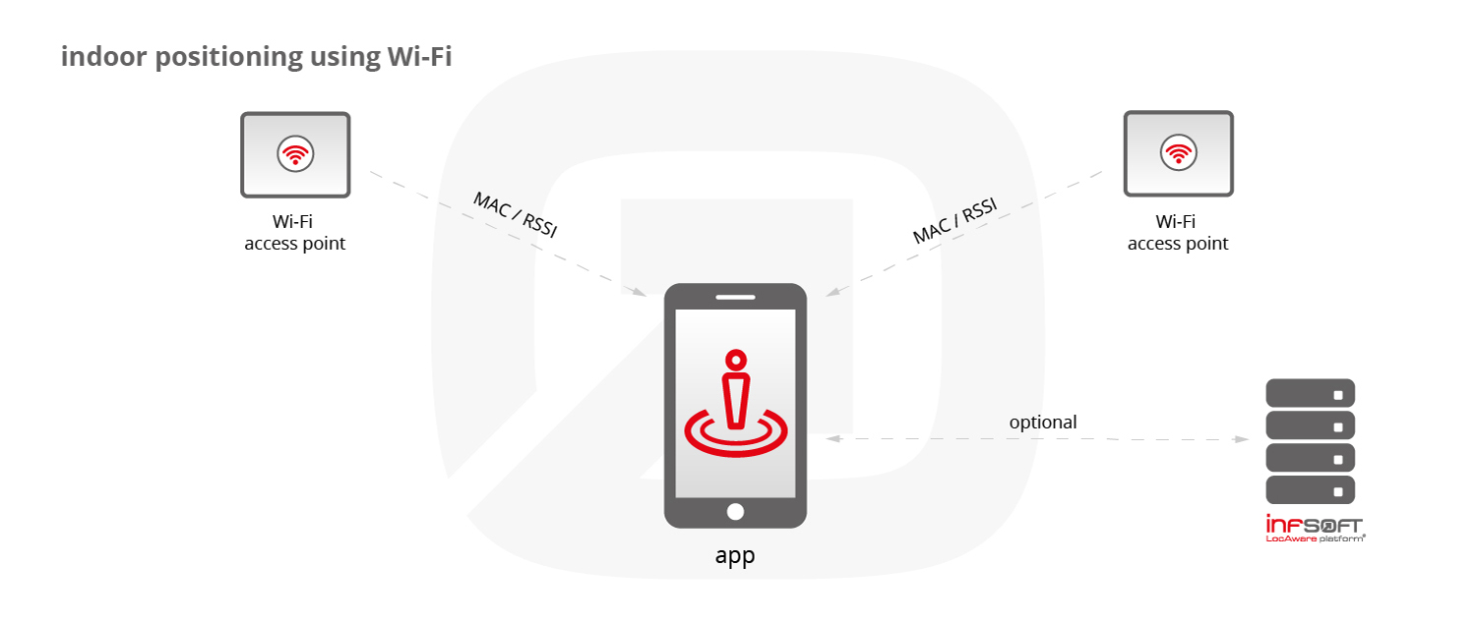

**Geomagnetic technology**

The magnetic field detection can also be used for indoor positioning by using a compass sensor. The so-called “fingerprinting” method is used for mapping magnetic fields at a particular place after which a smart device can use the same map in order to find indoor locations. This technique can be applied only in certain circumstances, where the magnetic fields indoors are stable.

IndoorAtlas is currently the only company that implements this technology. It is stated that the distortion of magnetic fields in buildings due to material they are made of was ideal for magnetic imprint . The more metal there is in the area, the imprint is more unique. It also said that the geomagnetic technology can be implemented in any indoor areas. Such a system does not require the installation of additional hardware. It is sufficient to pass through a room to collect data for magnetic positioning. The plan of the building is set on the cloud system and is connected with the magnetic imprints of the area. It takes about an hour to cover the 25,000 m2 of space (approximately 2,322 m2) in the accuracy of 1-2 meters. Non-technical staff members, any user, have also been enabled to generate magnetic imprint by using only their smart phone and instructions .

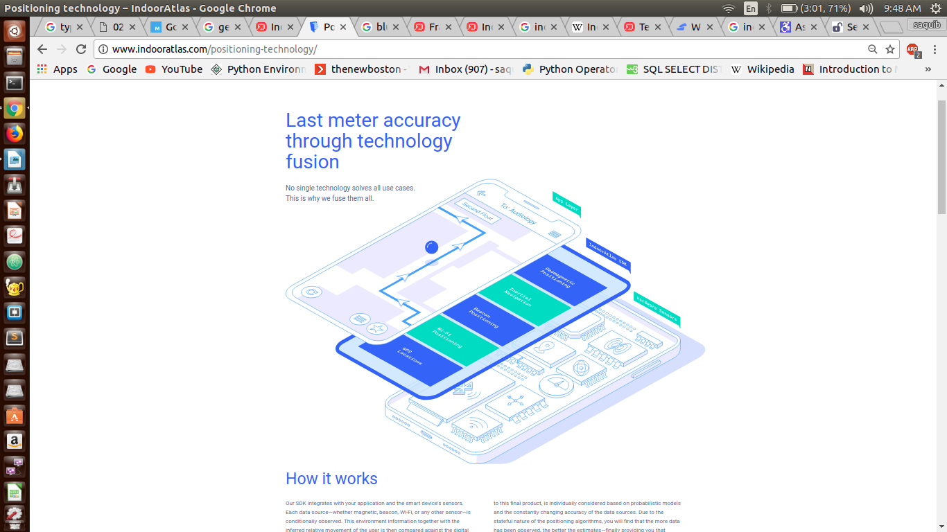

**VLC**

Visual Light Communication (VLC) is a wireless technology that uses LED light as a communication channel. Just like Wi-Fi technology, the term Li-Fi technology derived thereof. It can be used as a standalone solution or as an addition to radio communication (Wi-Fi, mobile). The VLC operates in a way that the LED switches from ON to OFF state and vice versa at a high frequency (nano seconds).

The LED sends a pattern of a blinking light received by a receiver, that is, a camera on a smart phone. The pattern is converted into an encrypted form and sent to the server. On the server, the encrypted form of the pattern is compared to the one on the map. When the identical encrypted form of the pattern is found on the map, the system implies that the user is positioned beneath the LED.

The downside of VLC technology is that the camera on the user’s device has to have visual contact with the LED. The device will not receive notification if visual contact is not achieved, as opposed to the BLE technology transmitter that does not require the same. VLC determines the location very accurately, even up to 5 cm

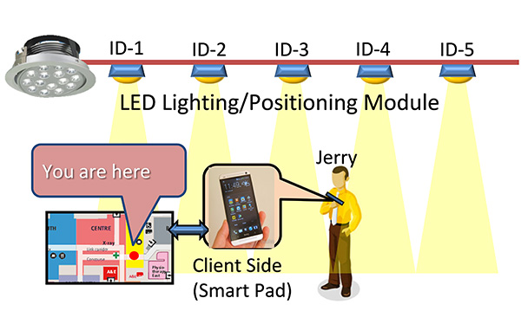

**A COMPARISON OF VARIOUS TECHNOLOGY**

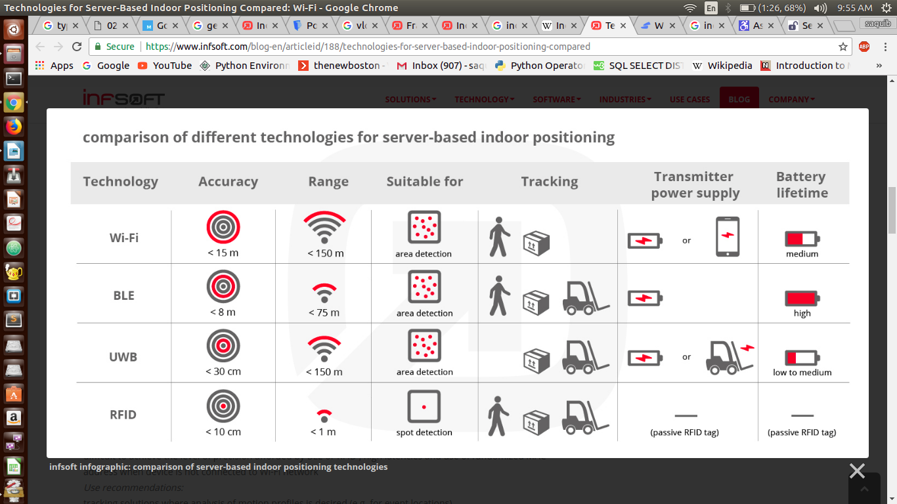

# Indoor Navigation & Services in Airports

### In the complex building structures of an airport, it is not always easy to keep track. Different terminals, the fastest way to the right check-in counter, the right gate – infsoft solutions can help in the best possible preparation for business trips or family vacations. The focus here is not solely on indoor navigation within the airport. For example, current flightinformation

### can ensure planning security for passengers and reduce stress. Free time can then be better used, e.g. for shopping, relaxing or working. A smooth outward journey can also be planned efficiently with an airport app while using the various means of transport, public or otherwise.

The navigation system inside the terminal displays the entire travel chain. Indoor navigation assists passengers starting with their arrival at a parking space or a public transport stop, to the check-in counter, on to the security checkpoints and then finally to the gate. All relevant POIs (points of interest) such as restrooms, ATMs, lounges, businesses or car rental agencies are provided on a digital map. The passenger sees his/her location as a blue point on the map and can be guided to various locations like a car's navigation system.

A smartphone app is just one option because the map material can also be integrated into a website as well as a touchscreen onsite (terminal solution/ multi touch kiosk). Thus the trip can be planned across devices. As an operator, you also benefit from detailed evaluations. Amongst other things, infsoft provides an automatic analysis of the waiting times at the security checkpoints and supports the help desk in passenger calls by transmitting their current position and displaying it within an interactive terminal map.

## Technical Implementation

The existing technical infrastructure can directly be used in many cases. Depending on the requirement, the operator choses a client-based (app is necessary, positioning via [Wi-Fi](https://www.infsoft.com/technology/sensors/wifi), Bluetooth beacons and sensor fusion, including a back channel) or a server-based solution. High-precision solutions with low latencies can be implemented on the basis of [Ultra-wideband (UWB)](https://www.infsoft.com/technology/sensors/ultra-wideband). The use of [RFID](https://www.infsoft.com/technology/sensors/rfid) is suitable for a point-specific object identification with high unit numbers.  
 Indoor navigation software by infsoft can be implemented in existing applications, websites and hospital information systems. The accuracy is – depending on the technical realization – up to ten centimetres or less.

# A running system provided by infsoft Frankfurt Airport (https://www.infsoft.com/industries/airports/success-story)

On behalf of [Frankfurt AG,](http://www.fraport.com/en.html) infsoft developed individual ANDROID and iOS apps with indoor positioning and indoor navigation for the third largest airport in Europe. The job was commissioned in 2011 and since then has continued to develop into a omni-channel solution, which now also comprises (responsive) website integration of the map material as well as interactive information media in the terminal (Interactive Airport Desk – "I-AID"). More than 61 million passengers annually profit from these services in an area of over 110 hectares. Approx. 1000 points of interest and approx. 30 kilometres of routes were digitally recorded.

## Functions of Frankfurt Airport App

* Check-in and gates as navigation destinations
* Real time flight information
* Shops, restaurants, lounges and facilities
* Parking assistant with tariff calculator
* “Around me" function
* Airport Online Shopping
* Interactive Airport Desk (I-AID)
* Boarding card scanning (I-AID and App)
* Sign Translator

**ANALYSIS OF TECHNOLOGICAL CHARACTERISTICS OF IPS**

**Location precision**

The precision (accuracy) of locating shows at what distances the indoor positioning is possible. The importance of the category depends on where the positioning system will be used. For example, if the user should be guided to a certain exit at the airport or to the doctor’s office, the precision of 2 or 5 meters should not be a problem. If a person should be guided to a specific product or a group of products, greater precision will be needed.

**Battery life**

With regard to the analysed technologies, only BLE transmitters use battery and its lifespan depends on the model of the transmitter, battery type and settings, and it may last for more than two years. The data on the cost of LED bulbs with VLC technology and the lifespan of a light bulb were not found in the source. The lifespan will depend on the wattage of a light bulb and estimated operating hours. If the light bulb has an estimated range of 50,000 operating hours, and if it is turned on 24 hours a day, the lifespan of a light bulb can be 5.7 years.

**Maintenance**

Maintenance may be analysed for BLE, Wi-Fi and VLC technologies since they are hardware components. Hardware components are not used in geomagnetic technology, so the maintenance may be more difficult to examine.

BLE technology requires skilled installers and constant calibration, depending on the changes in the observed area. Maintenance is made easier if management of the transmitters is centralized.

Given that the Wi-Fi infrastructure often already exists, maintenance of Wi-Fi technology for indoor positioning is facilitated. Current maintenance also includes the adjustment to changes in the environment and to infrastructure changes. This may be a malfunction of hardware or software, system upgrade or turning on or off of the access point if the router is controlled by a third party,e.g., the store owner at the mall (Luo et al, 2013).

The costs and maintenance of the VLC LED light bulbs are not significant. When the lifespan of the light bulb expires, it is replaced by a new one.

The hardware components may break down or be stolen, therefore, the replacement will be necessary. Wi-Fi and BLE transmitters are more exposed than the light bulbs.

**Installation costs**

When it comes to magnetic technology, the installation of the device is not needed, so there are no installation costs.

Regarding the VLC technology, costs can be high if all current luminaires are replaced. In terms of initial installation, the costs are not that high since there is also a need for the installation of luminaires. The price of a LED light bulb using VLC technology should be compared to a price of a normal light bulb in order to estimate the installation costs.

For Wi-Fi, installation costs are not high if one intends to use the existing infrastructure, or at least a part of it. If, however, access points are introduced only for those purposes, costs of devices and installations are observed as the cost of installation.

Depending on the model, strength and settings, the price of BLE transmitter ranges from 5-30 dollars for a piece . The unit price of the device is not high, but when it comes to IPS modelling, transmitter location will be defined, so, considering the quantity, the total cost of installation can be high.

**Mapping method**

Mapping a certain area in order to implement IPS. For Wi-Fi and VLC technology, it is necessary to map the area where the system will be installed and, if necessary, the system will be re-calibrated. In terms of BLE technology, similar procedures are carried out and applications for managing all devices are used when it comes to magnetic technology, users can independently collect data on magnetic fields which are then submitted to the manufacturer of the IPS. The data is then processed and made available for use. A user can introduce any change in the same way. The cost of such a technique of mapping area is not significant since it does not require field work of professional staff in order to map the area.

**Implementation indoor navigation system**

3 STEPS TO START

1. Add location

As the first step, you need to create a digital map of the target location. You need to have the precise floor plan and various sub location in your mind to proceed. This comes directly from the programmer and needs to cover the entire floor in vivid detail.

2. Setup infrastructure

In order to start implementation, you need to start deploying beacons, all the individual beacons will cover individual area (e.g. 10 Bluetooth beacons per 1000sqm of the floor) .These beacons have to be evenly deployed and linked to places on the floor plan via indoor map maker. The indoor map maker is a software that links the various beacons to the various places on the floor , it records data and store the different areas the beacons are covering.

### 3. Integrate SDK (Software developer kit)

Once the equipment is deployed, the map is uploaded, and both are interlinked, you can start developing your indoor navigation app.  Software development kit enables developers to create applications for the Android platform. The android **SDK** includes sample projects with source code, development tools, an emulator, and required libraries to build Android applications.

Inside buildings Wi-Fi is a good alternative to GPS, which is not available indoors. In most cases it is easy to install a Wi-Fi positioning system (WPS), since Wi-Fi access points already exist in many buildings. The advantage is that for example existing cash register systems, public hotspots and access points of shops or exhibitors can be used. The user doesn’t necessarily have to connect with the Wi-Fi, it is sufficient to have Wi-Fi enabled. For positioning, the so-called fingerprinting method is used. The strength of the Wi-Fi signals (received signal strength indication, RSSI) and the MAC address (media access control) are significant. There must be an appropriate app installed on the smartphone which calculates the current position based on these data. Later in this article you will learn about how these data are collected.

**ACCURACY OF WI-FI FOR INDOOR POSITIONING**

Accuracy depends on multiple factors, for example the number of available networks, reflections for example in corridors and last but not least shielding through walls, ceilings and your own body. The accuracy of Wi-Fi used for indoor positioning varies from five to 15 meters – depending on the preconditions. Sensor fusion – this means the use of smartphone sensors – can even improve accuracy. A big advantage compared to GPS is that it is possible to determine the current floor level.

SETTING UP AN INDOOR POSITIONING SYSTEM USING WI-FI

The calibration of position determination works with a one-time reference measurement in the run-up, where the signal strength of the Wi-Fi networks is determined. For this purpose infsoft offers an app with which the client can easily execute the measurement on his own. This solution is client based, which means an app is necessary. Check out our [developer portal](https://www.infsoft.com/developers) and the SDK for more information and videos.If a server based solution is more suitable for the project, infsoft’s self-developed locator nodes can be used. In this case no app is required, all Wi-Fi capable devices are detected and Wi-Fi tracking (asset tracking of, for example, mobile goods) is possible. Locator nodes also support Bluetooth low energy.

PROS AND CONS OF INDOOR POSITIONING USING WI-FI

**Pros:**

* existing Wi-Fi infrastructure can be used
* enabled Wi-Fi is sufficient
* there is a back channel to the client
* large range (up to 150m)
* detects floor level

**Cons**:

* relatively inaccurate (5-15m) compared to BLE/[RFID](https://www.infsoft.com/blog-en/articleid/60/indoor-tracking-using-beacons-or-rfid-what-are-the-differences)
* Wi-Fi client based positioning is not possible with iOS devices – but BLE can be used as an alternative.

**CONCLUSION**

Certain technologies used in the indoor positioning system have been presented in the paper. The very concept of the indoor positioning is quite new and it is difficult to say that one technology presents a standard. This domain is still being researched and such systems are reaching their market.

We have described IPS, its characteristics and its basic technologies. We have analysed technological characteristics of IPS on a few IPS examples. Results of the analyses shows that none of the analysed technologies achieve the best results according to all analysed characteristics, but BLE technology is the most favourable one. They may be divided mainly into two categories RF based solutions and IMU based solutions. RF based solutions are less accurate than IMU based solution. But the error remain constant throughout the usage. In IMU based solution the error is grows with long duration of usage.

For iBeacon based solution (using Bluetooth Beacons for triangulation) one can use estimate , for very good IMU based solution you can use oblu .

There are few other solutions as well but people prefers Beacon based solution where they can install the infrastructure before hand and IMU based solution where infrastructure before hand is not possible. So you need to make sure what is suitable for your application if it is infrastructure free positioning then go for IMU based positioning and if you can afford infrastructure for your applications then go for Beacon based system. Indoor location can be identified by the Bluetooth technology. GPS can be used to find the location for outdoor environment. Bluetooth technology acts key enabler for indoor environment to find the location inside the building or campus. Bluetooth terminal is connected to the network, it provide the location data inside the hotspot area. This application is used to know the information about the site of interest such as airports, bus station etc.

# BIBLIOGRAPHY

The sources from which references are taken :

https://www.infsoft.com

https://en.wikipedia.org/wiki/Indoor_positioning_system

indoorAtlas

<https://youtu.be/7xUERfmFHtc>

<https://youtu.be/npl9ObTUL7M>